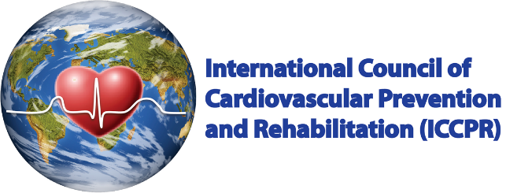
Dear Cardiac Rehab Participant:
Congratulations on your participation in our program. Here is a summary of how far you have come. Please share this with any other healthcare providers you may have.
From the beginning to the end of the program, your quality of life changed from ___ to ___ / 10. Your functional ability increased / decreased from the beginning to the end of the program. We hope you are feeling good!
You have improved your understanding of heart disease, but you still need to learn more or work on these areas: ________
We encourage you to continue your efforts to keep your heart healthy:
- Physical activity: you changed the number of minutes per week that you are active (being at least a bit short of breath) from the beginning of the program to the end by: ____. You should keep exercising at least 150 minutes per week, every week (your program can give you details on recommended frequency, duration and intensity you should exercise). Try to exercise most days, and limit the amount of time you spend sitting.
- Healthy diet: you changed the number of fruits and vegetables that you eat every day from the beginning of the program to the end by: ____. You should try to eat 5-10 servings every day. Remember to also avoid salt, processed foods, and red meat. Eat more fish, and meat alternatives such as beans, lentils, etc.
- Your shape: Based on your height, your weight is currently too high / just right. Continue to exercise and minimize the amount of food you eat, based on the recommendations above.
- Taking your pills: by the end of the program, you were taking your heart pills ____. You do/do not understand what heart pills you should be taking. We know it can be hard to remember to take your pills, to get them refilled and to pay for them. But these pills can help prolong your life, so keep working with your healthcare team to take your pills as directed.
- Medical risk factors: Make sure you keep monitoring your cholesterol and blood pressure, so they are below the target levels recommended by your doctor.
- Your well-being affects you and your heart: Be sure to keep engaging with friend and loved ones. Manage your stresses. If you are feeling worried, irritable or down, please reach out; there are effective treatments available and we can help.
Thank you for being an active partner in your rehabilitation with us. Please let us know if you have any questions about this summary. Remember to seek healthcare if you experience heart symptoms. Please continue to see a healthcare provider regularly to keep on track.
You may receive another contact from us a year from when you started your program to check in how you are doing. If your contact information changes during that time, please email us to let us know at iccpr.icrr@gmail.com. They can also answer any questions you may have about the registry.
We hope participating in our program has been helpful to you, and will help you to continue your heart healthy lifestyle.
Sincerely,
Your Rehab Team & the International Cardiac Rehab Registry

